USING A CALCULATOR
Pearson Edexcel - Monday 12 November 2018 - Paper 3 (Calculator) Higher Tier
1.
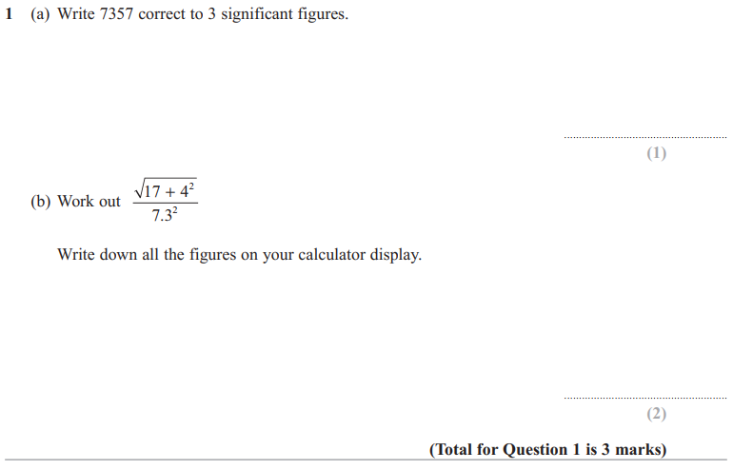
Pearson Edexcel - Monday 6 November 2017 - Paper 2 (Calculator) Higher Tier
2.
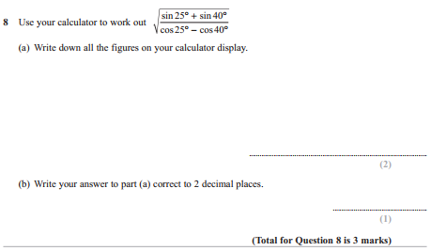
Pearson Edexcel - Thursday 25 May 2017 - Paper 1 (Non-Calculator) Higher Tier
3.
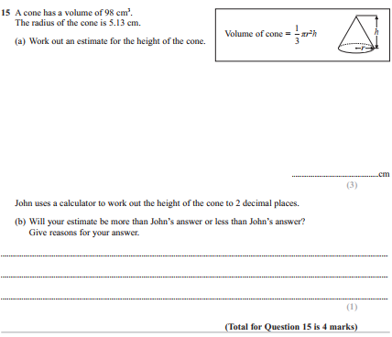
Pearson Edexcel - Monday 8 June 2015 - Paper 2 (Calculator) Higher Tier
4.
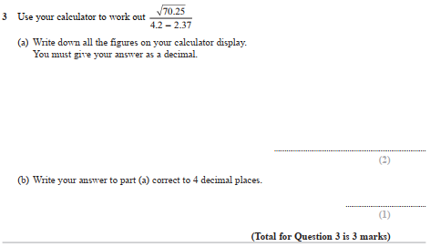

Pearson Edexcel - Friday 13 June 2014 - Paper 2 (Calculator) Higher Tier
5.
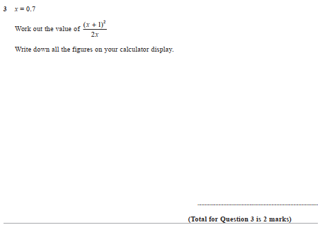

Pearson Edexcel - Friday 8 November 2013 - Paper 2 (Calculator) Higher Tier
6.
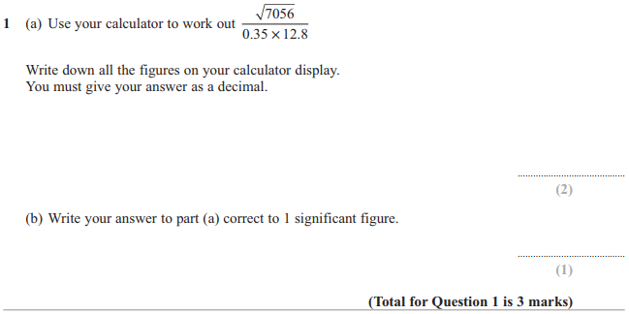

Pearson Edexcel - Monday 4 March 2013 - Paper 2 (Calculator) Higher Tier
7.
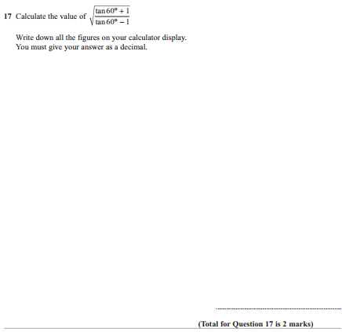

Pearson Edexcel - Thursday 8 November 2012 - Paper 2 (Calculator) Higher Tier
8.
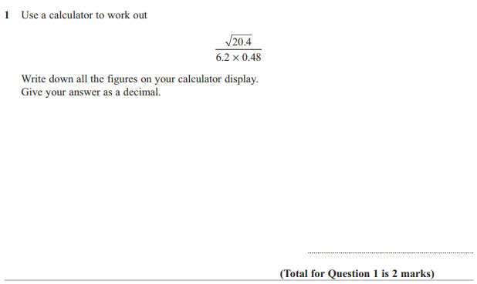

Pearson Edexcel - Wednesday 13 June 2012 - Paper 2 (Calculator) Higher Tier
9.
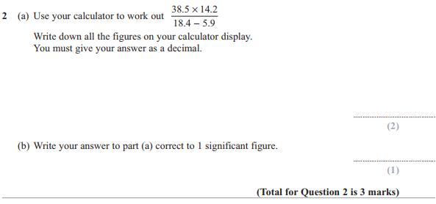

Pearson Edexcel - Monday 5 March 2012 - Paper 4 (Calculator) Higher Tier
10.
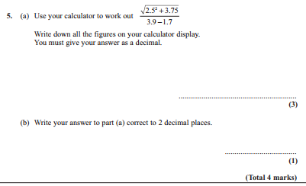
Pearson Edexcel - Monday 14 November 2011 - Paper 4 (Calculator) Higher Tier
11.
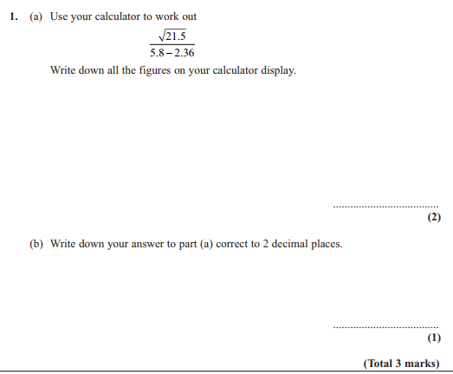
Pearson Edexcel - Friday 10 June 2011 - Paper 4 (Calculator) Higher Tier
12.
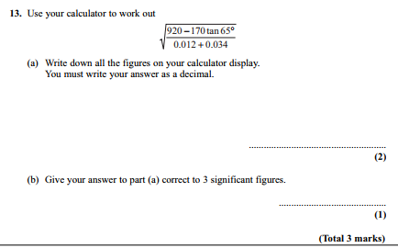

Pearson Edexcel - Friday 12 November 2010 - Paper 4 (Calculator) Higher Tier
13.
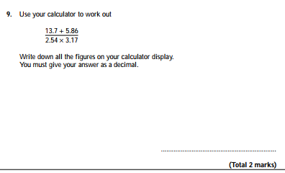
Pearson Edexcel - Friday 11 June 2010 - Paper 4 (Calculator) Higher Tier
14.
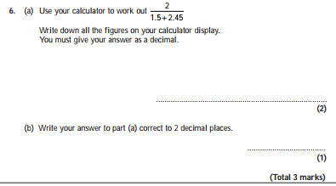

Pearson Edexcel - Tuesday 10 November 2009 - Paper 4 (Calculator) Higher Tier
15.
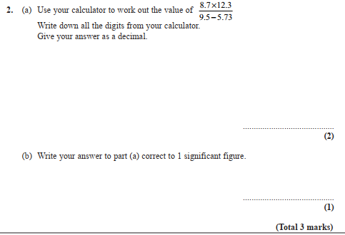

OCR GSCE – Sample Papers – Paper 4 (Calculator) Higher Tier
16.
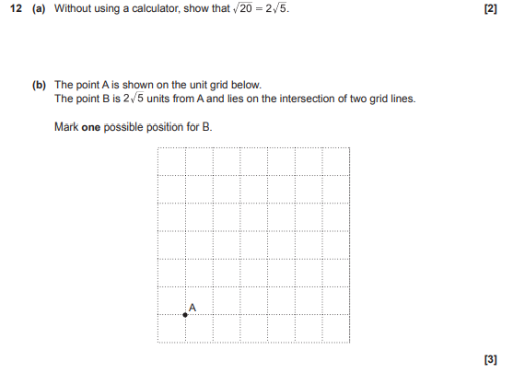

AQA GSCE – Thursday 8 November 2018 – Paper 2 (Calculator) Higher Tier
17.
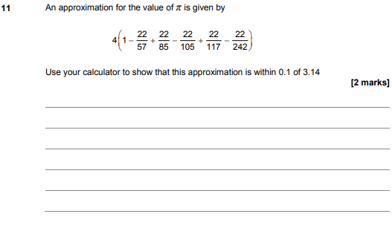
AQA GSCE – Sample Paper 3 (Calculator) Higher Tier
18.
